GPS

GPS (GOBAL POSITIONING SYSTEM):
In order to find out the latitude and longitude of the present BUS location at which we are located it soon became very evident that there had to be a better solution to the problem of locating and obtaining an accurate and absolute position.
Location -to determine a basic position.
Navigation –to get from one location to another.
Tracking –to monitor the movement of people and things.
Mapping –to create maps of the world.
Timing –to bring precise timing to the world.

In the early 1970’s, the DoDproposed a Global Positioning System (GPS) called NAVSTAR (NAVigationSatellite Timing And Ranging).The first NAVSTAR satellite was launched by the U.S. Air Force in early 1978 for military use.NAVSTAR was expanded for civilian use in the 1980’s.In 1994, a full constellation of 24 satellites was achieved.

The GPS receiver receives theradio signals and uses Isaac Newton’s Law of Motion to calculate the distance to each satellite.
Velocity x Time = Distance
Velocity = Speed of the radio frequencies (186,000 mi/sec).
Time = Difference between when the radio signals were sent by the satellites and when they were received by the GPS receiver.

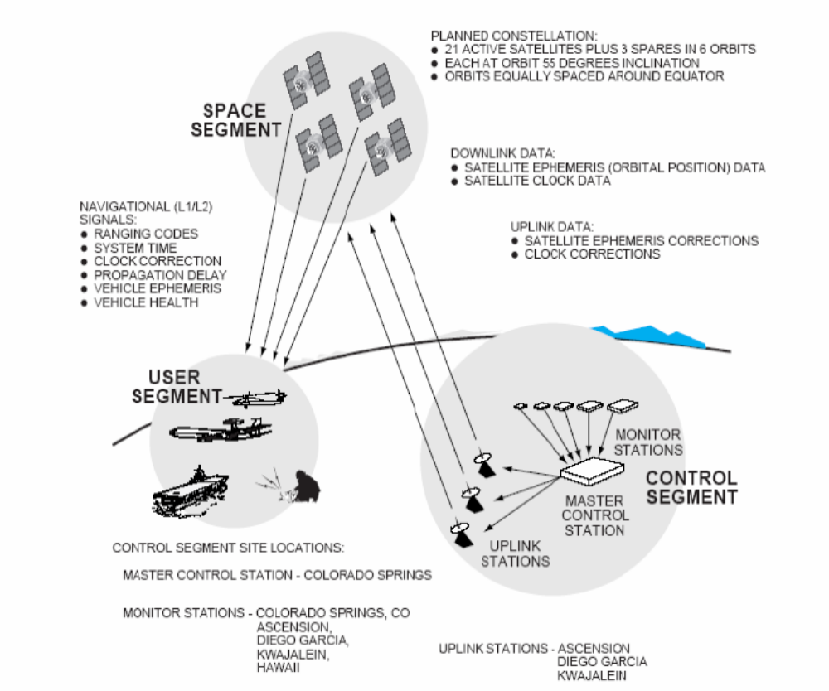

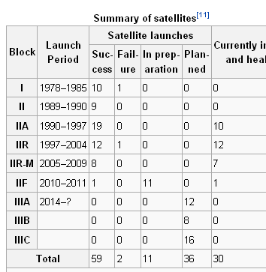

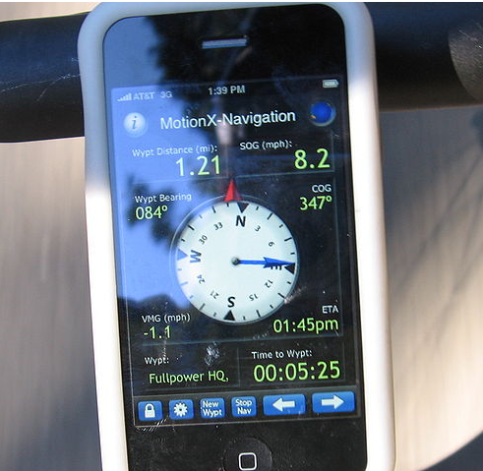

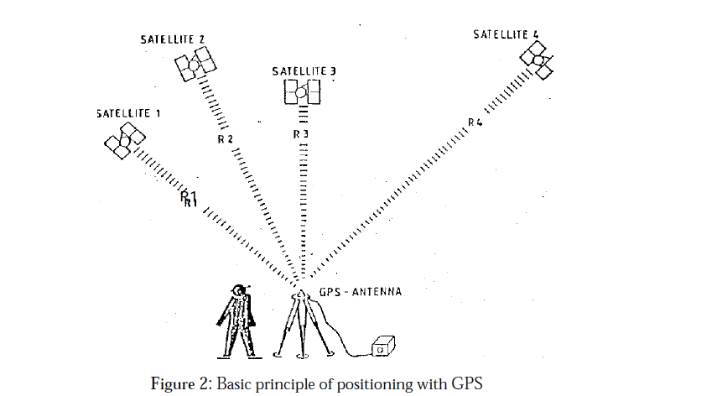

BASIC CONCEPT OF GPS RECEIVER AND ITS COMPONENTS:

- The main components of a GPS receiver these are:
- Antenna with pre-amplifier

- RF section with signal identification and signal processing

- Micro-processor for receiver control, data sampling and data processing

- Precision oscillator

- Power supply

- User interface, command and display panel

- Memory, data storage

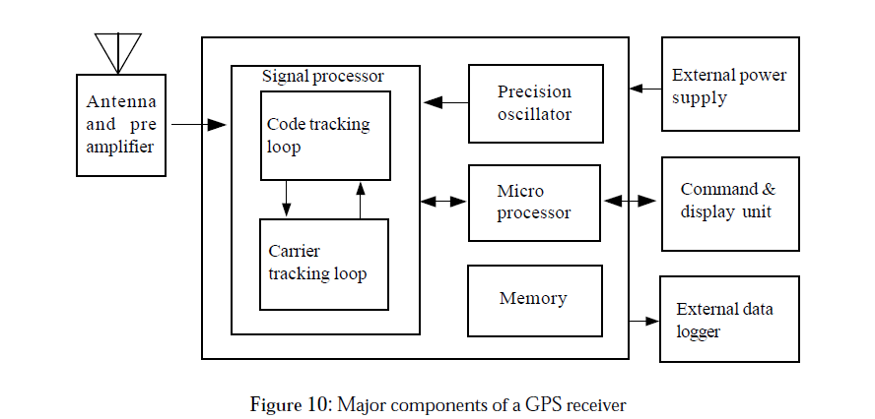

Antenna:

Sensitive antenna of the GPS receiver detects the electromagnetic wave signal transmitted by GPS satellites and converts the wave energy to electric current] amplifies the signal strength and sends them to receiver electronics.
- Mono pole or dipole
  - Quadrifilar helix (Volute)
  - Spiral helix
  - Microstrip (patch)
  - Choke ring

Microstrip antennas are most frequently used because of its added advantage for airborne application, materialization of GPS receiver and easy construction. However, for geodetic needs, antennas are designed to receive both carrier frequencies L1 and L2. Also they are protected against multipath by extra ground planes or by using choke rings. A choke ring consists of strips of conductor which are concentric with the vertical axis of the antenna and connected to the ground plate which in turns reduces the multipath effect.
RF Section with Signal Identification and Processing:

The incoming GPS signals are down converted to a lower frequency in the RS section and processed within one or more channels. Receiver channel is the primary electronic unit of a GPS receiver. A receiver may have one or more channels. In the parallel channel concept each channel is continuously franking one particular satellite. A minimum of four parallel channels is required to determine position and time. Modern receivers contain up to 12 channels for each frequency. In the sequencing channel concept the channel switches from satellite to satellite at regular interval. A single channel receiver takes at least four times of 30 seconds to establish first position fix, though some receiver types have a dedicated channel for reading the data signal. Now days in most of the cases fast sequencing channels with a switching rate of about one-second per satellite are used. In multiplexing channel, sequencing at a very high speed between different satellites is achieved using one or both frequencies. The switching rate is synchronous with the navigation message of 50 bps or 20 milliseconds per bit. A complete sequence with four satellites is completed by 20 millisecond or after 40 millisecond for dual frequency receivers. The navigation message is continuous, hence first fix is achieved after about 30 seconds. Though continuous tracking parallel channels are cheap and give good overall performance, GPS receivers based on multiplexing technology will soon be available at a cheaper price due to electronic boom.

Microprocessor:

To control the operation of a GPS receiver, a microprocessor is essential for acquiring the signals, processing of the signal and the decoding of the broadcast message. Additional capabilities of computation of on-line position and velocity, conversion into a given local datum or the determination of waypoint information are also required. In future more and more user relevant software will be resident on miniaturized memory chips.
Precision Oscillator:
A reference frequency in the receiver is generated by the precision oscillator. Normally, less expensive, low performance quartz oscillator is used in receivers since the precise clock information is obtained from the GPS satellites and the user clock error can be eliminated through double differencing technique when all participating receivers observe at exactly the same epoch. For navigation with two or three satellites only an external high precision oscillator is used.

Power Supply:
First generation GPS receivers consumed very high power, but modern receivers are designed to consume as little energy as possible. Most receivers have an internal rechargeable Nickel Cadmium battery in addition to an external power input. Caution of low battery signal prompts the user to ensure adequate arrangement of power supply.

Memory Capacity:

For port processing purposes all data have to be stored on internal or external memory devices. Post processing is essential for multi station techniques applicable to geodetic and surveying problems. GPS observation for pseudo ranges, phase data, time and navigation message data have to be recorded. Based on sampling rate, it amount to about 1.5 Mbytes of data per hour for six satellites and 1 second data for dual frequency receivers. Modern receivers have internal memories of 5 Mbytes or more. Some receivers store the data on magnetic tape or on a floppy disk or hard-disk using external microcomputer connected through RS-232 port. Most modern receivers have a keypad and a display for communication between the user and the receivers. The keypad is used to enter commands, external data like station number or antenna height or to select a menu operation. The display indicates computed coordinates, visible satellites, data quality indices and other suitable information. Current operation software packages are menu driven and very user friendly.

Classification of GPS Receivers:

GPS receivers can be divided into various groups according to different criteria. In the early stages two basic technologies were used as the classification criteria viz. Code correlation receiver technology and sequencing receiver technology, which were equivalent to code dependent receivers and code free receivers. However, this kind of division is no longer justifiable since both techniques are implemented in present receivers.

Examples of GPS Receiver:

GPS receiver market is developing and expanding at a very high speed. Receivers are becoming powerful, cheap and smaller in size. It is not possible to give details of every make but description of some typical receivers given may be regarded as a basis for the evaluation of future search and study of GPS receivers.

Classical Receivers:

Detailed description of code dependent T1 4100 GPS Navigator and code free Micrometer V1000 is given here:



The Global Positioning System (GPS) is a satellite-based navigation system made up of a network of 24 satellites placed into orbit by the U.S. Department of Defense. GPS was originally intended for military applications, but in the 1980s, the government made the system available for civilian use. GPS works in any weather conditions, anywhere in the world, 24 hours a day. There are no subscription fees or setup charges to use GPS.
How it works:
GPS satellites circle the earth twice a day in a very precise orbit and transmit signal information to earth. GPS receivers take this information and use triangulation to calculate the user's exact location. Essentially, the GPS receiver compares the time a signal was transmitted by a satellite with the time it was received. The time difference tells the GPS receiver how far away the satellite is. Now, with distance measurements from a few more satellites, the receiver can determine the user's position and display it on the unit's electronic map.
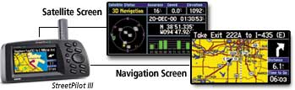

A GPS receiver must be locked on to the signal of at least three satellites to calculate a 2D position (latitude and longitude) and track movement. With four or more satellites in view, the receiver can determine the user's 3D position (latitude, longitude and altitude). Once the user's position has been determined, the GPS unit can calculate other information, such as speed, bearing, track, trip distance, distance to destination, sunrise and sunset time and more.
How accurate is GPS:
Today's GPS receivers are extremely accurate, thanks to their parallel multi-channel design. Garmin's 12 parallel channel receivers are quick to lock onto satellites when first turned on and they maintain strong locks, even in dense foliage or urban settings with tall buildings. Certain atmospheric factors and other sources of error can affect the accuracy of GPS receivers. Garmin® GPS receivers are accurate to within 15 meters on average.

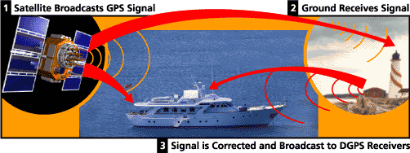

Newer Garmin GPS receivers with WAAS (Wide Area Augmentation System) capability can improve accuracy to less than three meters on average. No additional equipment or fees are required to take advantage of WAAS. Users can also get better accuracy with Differential GPS (DGPS), which corrects GPS signals to within an average of three to five meters. The U.S. Coast Guard operates the most common DGPS correction service. This system consists of a network of towers that receive GPS signals and transmit a corrected signal by beacon transmitters. In order to get the corrected signal, users must have a differential beacon receiver and beacon antenna in addition to their GPS.
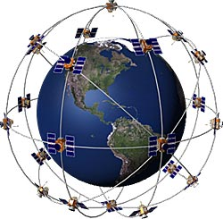
The GPS satellite system:
The 24 satellites that make up the GPS space segment are orbiting the earth about 12,000 miles above us. They are constantly moving, making two complete orbits in less than 24 hours. These satellites are travelling at speeds of roughly 7,000 miles an hour.
GPS satellites are powered by solar energy. They have backup batteries onboard to keep them running in the event of a solar eclipse, when there's no solar power. Small rocket boosters on each satellite keep them flying in the correct path.
Here are some other interesting facts about the GPS satellites (also called NAVSTAR, the official U.S. Department of Defense name for GPS):
The first GPS satellite was launched in 1978.
A full constellation of 24 satellites was achieved in 1994.
Each satellite is built to last about 10 years. Replacements are constantly being built and launched into orbit.
A GPS satellite weighs approximately 2,000 pounds and is about 17 feet across with the solar panels extended.
Transmitter power is only 50 watts or less.
What's the signal:
GPS satellites transmit two low power radio signals, designated L1 and L2. Civilian GPS uses the L1 frequency of 1575.42 MHz in the UHF band. The signals travel by line of sight, meaning they will pass through clouds, glass and plastic but will not go through most solid objects such as buildings and mountains.
A GPS signal contains three different bits of information - a pseudorandom code, ephemeris data and almanac data. The pseudorandom code is simply an I.D. code that identifies which satellite is transmitting information. You can view this number on your Garmin GPS unit's satellite page, as it identifies which satellites it's receiving.
Ephemeris data, which is constantly transmitted by each satellite, contains important information about the status of the satellite (healthy or unhealthy), current date and time. This part of the signal is essential for determining a position.
The almanac data tells the GPS receiver where each GPS satellite should be at any time throughout the day. Each satellite transmits almanac data showing the orbital information for that satellite and for every other satellite in the system.
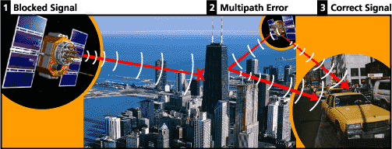

Sources of GPS signal errors:

Factors that can degrade the GPS signal and thus affect accuracy include the following:
Ionosphere and troposphere delays - The satellite signal slows as it passes through the atmosphere. The GPS system uses a built-in model that calculates an average amount of delay to partially correct for this type of error.
Signal multipath - This occurs when the GPS signal is reflected off objects such as tall buildings or large rock surfaces before it reaches the receiver. This increases the travel time of the signal, thereby causing errors.
Receiver clock errors - A receiver's built-in clock is not as accurate as the atomic clocks onboard the GPS satellites. Therefore, it may have very slight timing errors.
Orbital errors - Also known as ephemeris errors, these are inaccuracies of the satellite's reported location.
Number of satellites visible - The more satellites a GPS receiver can "see," the better the accuracy. Buildings, terrain, electronic interference, or sometimes even dense foliage can block signal reception, causing position errors or possibly no position reading at all. GPS units typically will not work indoors, underwater or underground.
Satellite geometry/shading - This refers to the relative position of the satellites at any given time. Ideal satellite geometry exists when the satellites are located at wide angles relative to each other. Poor geometry results when the satellites are located in a line or in a tight grouping.
Intentional degradation of the satellite signal - Selective Availability (SA) is an intentional degradation of the signal once imposed by the U.S. Department of Defense. SA was intended to prevent military adversaries from using the highly accurate GPS signals. The government turned off SA in May 2000, which significantly improved the accuracy of civilian GPS receivers.
Applications:
While originally a military project, GPS is considered a dual-use technology, meaning it has significant military and civilian applications.
GPS has become a widely deployed and useful tool for commerce, scientific uses, tracking, and surveillance. GPS's accurate time facilitates everyday activities such as banking, mobile phone operations, and even the control of power grids by allowing well synchronized hand-off switching. Farmers, surveyors, geologists, and countless others perform their work more efficiently, safely, economically, and accurately.^{[25]}
Communication:
The navigational signals transmitted by GPS satellites encode a variety of information including satellite positions, the state of the internal clocks, and the health of the network. These signals are transmitted on two separate carrier frequencies that are common to all satellites in the network. Two different encodings are used, a public encoding that enables lower resolution navigation, and an encrypted encoding used by the U.S. military.
Message format:

Each GPS satellite continuously broadcasts a navigation message at a rate of 50 bits per second (see bitrate). Each complete message is composed of 30-second frames, distinct groupings of 1,500 bits of information. Each frame is further subdivided into 5 sub frames of length 6 seconds and with 300 bits each. Each sub frame contains 10 words of 30 bits with length 0.6 seconds each. Each 30 second frame begins precisely on the minute or half minute as indicated by the atomic clock on each satellite.^{[55]}
GPS message format
Sub frames | Description
1 | Satellite clock,  GPS time relationship
2–3 | Ephemeris  (precise satellite orbit)
4–5 | Almanac component  (satellite network synopsys,  error correction)
The first part of the message encodes the week number and the time within the week,^{[56]} as well as the data about the health of the satellite. The second part of the message, the ephemeris, provides the precise orbit for the satellite. The last part of the message, the almanac, contains coarse orbit and status information for all satellites in the network as well as data related to error correction.^{[57]}
All satellites broadcast at the same frequencies. Signals are encoded using code division multiple access (CDMA) allowing messages from individual satellites to be distinguished from each other based on unique encodings for each satellite (that the receiver must be aware of). Two distinct types of CDMA encodings are used: the coarse/acquisition (C/A) code, which is accessible by the general public, and the precise (P) code, that is encrypted so that only the U.S. military can access it.
The ephemeris is updated every 2 hours and is generally valid for 4 hours, with provisions for updates every 6 hours or longer in non-nominal conditions. The almanac is updated typically every 24 hours. Additionally data for a few weeks following is uploaded in case of transmission updates that delay data upload.

